LOOK BACK

With just 60 feet between bases, this rule prevents any cat-and-mouse games between runners and the pitcher. The intent of the rule is to require baserunners to return to a base or continue to advance toward another base when the pitcher receives the ball within the circle.

MUSTS!
- Ball is live.
- Batter-runner has reached first base (or has been declared out if that occurs first).
- Pitcher has possession of the ball with both feet (completely or partially) within the pitcher’s circle.

KEY TERMS
- A batter-runner who rounds first base toward second base can stop, but then must immediately, without stopping again, return to first or attempt to advance to second base.
- A batter-runner who overruns first base toward right field, turns left and moves directly toward second base and stops is committed to second and must attempt to advance to second base.

DON’T FORGET
Umpires should not call time, even if requested, until the pitcher has possession of the ball in the circle.
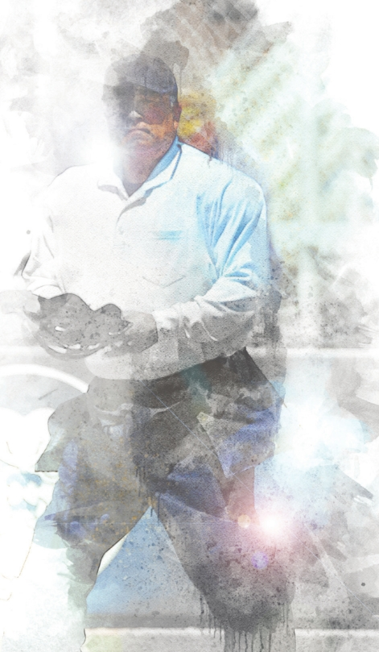

ALL BETS OFF!
The pitcher, in control of the ball, initiates action to cause a reaction (fakes a throw on a baserunner), attempts to make a play on the runner or loses control of the ball. When that happens, the look-back rule is not in effect.

