ILLEGAL PITCHES

HERE’S THE PITCH ON WHAT’S ILLEGAL RULE 04
Consider an illegal pitch as softball’s version of a defensive offside penalty in pro football when the offense suddenly has a “free play.” That team will have a choice to take a bigger than five-yard gain as a result of the play or nullify the play and accept the penalty for offside. Pretty much the same thing in softball. When the pitcher does something illegal before or while delivering a pitch, the offense will benefit in one way or the other. A ball is awarded to the batter or if the batter reaches first base on a hit and all other runners advance at least one base, the illegal pitch is nullified.

MYTH
A pitcher must wipe after using rosin to dry her hand/fingers.

REALITY
NFHS, USA Softball and USSSA do not require the pitcher to wipe her fingers after using rosin.

WHAT’S AN ILLEGAL PITCH?
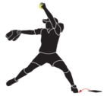
Crow hop. When a pitcher steps or hops with her pivot foot completely off the front of the rubber and replants the pivot foot and establishes new impetus to push off in a new delivery motion not related to the original movement from the pitcher’s plate.
Leaping. The pitcher may not become airborne with both feet at the same time on the initial drive from the pitcher’s plate. The pivot foot must slide or drag on the ground.
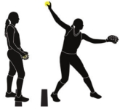
Replant. When the pitcher uses a small hop forward with her pivot foot while maintaining contact with the ground and replanting the pivot foot in front of the pitching plate for a new push-off point.
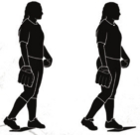
Taking the signal. It is an illegal pitch if the hands are not separated when the pitcher steps onto the plate to take a signal from the catcher or fails to pause to simulate taking a signal.
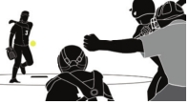
Outside the 24-inch width of pitching lane. The pitcher must take a step with the non-pivot foot toward the batter but within the 24-inch length of the pitcher’s plate. She must keep the pivot foot in contact with the ground while dragging away from the plate.
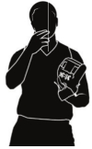
No wipe. If the pitcher goes to her mouth with the pitching fingers, she must wipe them off before touching the ball.

IF THE PITCH IS RELEASED, THE UMPIRE WILL GIVE THE DELAYED-DEAD BALL SIGNAL AND VERBALIZE, “ILLEGAL PITCH.” TIME IS CALLED AFTER THE PLAY AND PENALTIES ARE ADMINISTERED.

